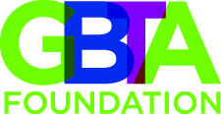

Chris Ely
Director, Research

Chris Ely directs the research division at GBTA. Chris has over 15 years of professional experience conducting both qualitative and quantitative research. Prior to joining GBTA, Chris was the research director at BDS Marketing where he conducted quantitative research studies for clients seeking to increase their market share and sales. He also worked at the Consumer Technology Association for ten years where he conducted qualitative and quantitative research studies on a host of technology topics. Chris is a seasoned speaker having presented research findings and trends at numerous industry events across the country.
Chris received a Bachelor of Arts degree from Earlham College and a Master of Arts degree from the University of Denver.

